How Parse Works

IOS
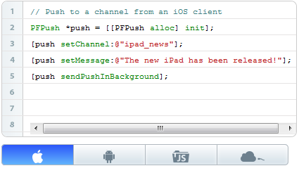

Android
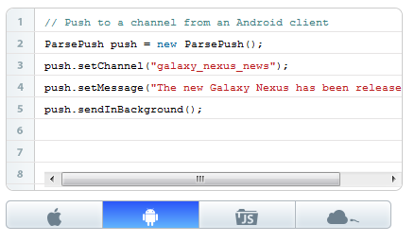

JS
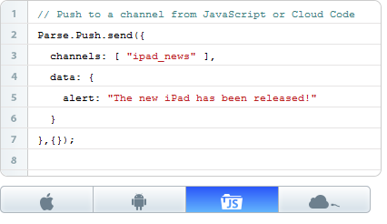

Cloud
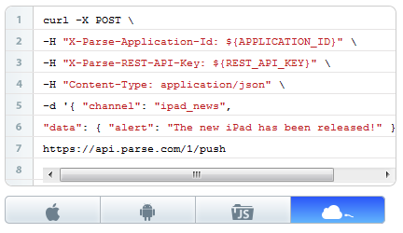

Data requirements for Set Up
While it is possible to modify a PFInstallation just like you would a PFObject, there are several special fields that help manage and target devices.
- channels: An array of the channels to which a device is currently subscribed.
- badge: The current value of the icon badge for iOS/OS X apps. Changing this value on the PFInstallation will update the badge value on the app icon. Changes should be saved to the server so that they will be used for future badge-increment push notifications.
- installationId: Unique Id for the device used by Parse (readonly).
- deviceType: The type of device, "ios", "osx", "android", "winrt", "winphone", "dotnet", or "embedded". On iOS and OS X devices, this field will be set to "ios" and "osx", respectively (readonly).
- deviceToken: The Apple generated token used for iOS/OS X devices. On Android devices, this is the token used by GCM to keep track of registration ID (readonly).
- appName: The display name of the client application to which this installation belongs. In iOS/OS X, this value is obtained from kCFBundleNameKey. This value is synchronized every time an PFInstallation object is saved from the device (readonly).
- appVersion: The version string of the client application to which this installation belongs. In iOS/OS X, this value is obtained from kCFBundleVersionKey. This value is synchronized every time an PFInstallation object is saved from the device (readonly).
- appIdentifier: A unique identifier for this installation's client application. In iOS/OS X, this value is obtained from kCFBundleIdentifierKey. This value is synchronized every time an PFInstallation object is saved from the device (readonly).
- parseVersion: The version of the Parse SDK which this installation uses. This value is synchronized every time an PFInstallation object is saved from the device (readonly).
- timeZone: The current time zone where the target device is located. This value is synchronized every time an PFInstallation object is saved from the device (readonly).
- localeIdentifier: The locale identifier of the device in the format [language code]-[COUNTRY CODE]. The language codes are two-letter lowercase ISO language codes (such as "en") as defined by ISO 639-1. The country codes are two-letter uppercase ISO country codes (such as "US") as defined by ISO 3166-1. This value is synchronized every time an PFInstallation object is saved from the device (readonly).
- pushType: This field is reserved for directing Parse to the push delivery network to be used for Android devices. This parameter is not supported in iOS/OS X devices (readonly).
- GCMSenderId: This field only has meaning for Android PFInstallations that use the GCM push type. This parameter is not supported in iOS/OS X devices.
- channelUris: The Microsoft-generated push URIs for Windows devices (readonly).

curl -X POST \
-H "X-Parse-Application-Id: cI2U1BzqQNpdN948YjETej1w0wPQaXqD5fG7xLEn" \
-H "X-Parse-REST-API-Key: 8aq5NgqJJvD3q2Y8YSIWEKOMh4nz3BktCle96swT" \
-H "X-Parse-Session-Token: r:pnktnjyb996sj4p156gjtp4im" \
https://api.parse.com/1/logout

curl -X POST \
-H "X-Parse-Application-Id: cI2U1BzqQNpdN948YjETej1w0wPQaXqD5fG7xLEn" \
-H "X-Parse-REST-API-Key: 8aq5NgqJJvD3q2Y8YSIWEKOMh4nz3BktCle96swT" \
-H "Content-Type: application/json" \
-d '{
"deviceType": "ios",
"deviceToken": "0123456789abcdef0123456789abcdef0123456789abcdef0123456789abcdef",
"channels": [
""
]
}' \
https://api.parse.com/1/installations

